**Heritage Institute of Technology**

***(An Autonomous Institute)***

**Department** **of**

**Electronics and Communication Engineering**



**Quantum Cancer Diagnostics –**

**Quantum Inspired Vision Based Web Application for Breast Cancer Histopathological Image Classification**

***Affiliated***

***to***

### [*Maulana Abul Kalam Azad University of Technology*](https://www.google.co.in/url?sa=t&rct=j&q=&esrc=s&source=web&cd=13&cad=rja&uact=8&ved=0ahUKEwiSuPnr8IrLAhUVkY4KHa5nDgUQFgg5MAw&url=https%3A%2F%2Fen.wikipedia.org%2Fwiki%2FMaulana_Abul_Kalam_Azad_University_of_Technology&usg=AFQjCNEkOWkuufv7TcM66ZvXxWdAunaASw&sig2=o5erv91mScoD8FHMGk2RRw)

### *(Formerly WBUT), 2025*

**Name : Snigdha Paul**

**Sambit Mallick**

**Swarnendu Sil**

**Roll No : 12621003121, 12621003096, 12621003145**

**Registration No : 211260100310014, 211260100310152, 211260100310010**

**Heritage Institute of Technology**

***(An Autonomous Institute)***

**Department** **of**

**Electronics and Communication Engineering**



***This is to certify that the project report***

**Quantum Cancer Diagnostics –**

**Quantum Inspired Vision Based Web Application for Breast Cancer Histopathological Image Classification**

***Has been successfully completed by***

**Name : Snigdha Paul**

**Sambit Mallick**

**Swarnendu Sil**

**Roll No : 12621003121, 12621003096, 12621003145**

**Registration No : 211260100310014, 211260100310152, 211260100310010**

***In partial fulfillment for the award of the degree in***

***Bachelor of Technology***

**In**

***Electronics and Communication Engineering***

### [*Maulana Abul Kalam Azad University of Technology*](https://www.google.co.in/url?sa=t&rct=j&q=&esrc=s&source=web&cd=13&cad=rja&uact=8&ved=0ahUKEwiSuPnr8IrLAhUVkY4KHa5nDgUQFgg5MAw&url=https%3A%2F%2Fen.wikipedia.org%2Fwiki%2FMaulana_Abul_Kalam_Azad_University_of_Technology&usg=AFQjCNEkOWkuufv7TcM66ZvXxWdAunaASw&sig2=o5erv91mScoD8FHMGk2RRw)

### *(Formerly WBUT), 2025*

***Under the Supervision of***

Prof. Dr. Anindya Sen

Professor, ECE Dept, HITK

Dept. of Electronic and Communication Engineering

Heritage Institute of Technology, Kolkata-700107.



*Certificate of Recommendation*

This is to certify that the Thesis entitled ***“Quantum Cancer Diagnostics – Quantum Inspired Vision Based Web Application for Breast Cancer Histopathological Image Classification”*** submitted by **Snigdha Paul, Sambit Mallick, Swarnendu Sil** under the supervision of ***Prof. Anindya Sen*** (Professor, Dept. of ECE, HITK), has been prepared according to the regulations of **B.Tech. Degree** in **Electronics and Communication Engineering Department**, awarded by [**Maulana Abul Kalam Azad University of Technology**](https://www.google.co.in/url?sa=t&rct=j&q=&esrc=s&source=web&cd=13&cad=rja&uact=8&ved=0ahUKEwiSuPnr8IrLAhUVkY4KHa5nDgUQFgg5MAw&url=https%3A%2F%2Fen.wikipedia.org%2Fwiki%2FMaulana_Abul_Kalam_Azad_University_of_Technology&usg=AFQjCNEkOWkuufv7TcM66ZvXxWdAunaASw&sig2=o5erv91mScoD8FHMGk2RRw) **(Formerly WBUT)** and he has fulfilled the requirements for submission of thesis report and that neither his/her thesis report has been submitted for any degree or any other academic award anywhere before.

## *…………………………………………………….………*

**Prof. Anindya Sen**

(Designation, Dept of ECE, HITK)

***Project Supervisor***

## *.………………………………*

## **Prof. Prabir Banerjee**

(HOD, Dept of ECE, HITK)

**Heritage Institute of Technology**

***(An Autonomous Institute)***

***Affiliated to***

### [Maulana Abul Kalam Azad University of Technology](https://www.google.co.in/url?sa=t&rct=j&q=&esrc=s&source=web&cd=13&cad=rja&uact=8&ved=0ahUKEwiSuPnr8IrLAhUVkY4KHa5nDgUQFgg5MAw&url=https%3A%2F%2Fen.wikipedia.org%2Fwiki%2FMaulana_Abul_Kalam_Azad_University_of_Technology&usg=AFQjCNEkOWkuufv7TcM66ZvXxWdAunaASw&sig2=o5erv91mScoD8FHMGk2RRw)

(Formerly WBUT)



***Certificate of Approval\****

The foregoing thesis report is hereby approved as a creditable study of an engineering subject carried out and presented in a manner satisfactory to warrant its acceptance as a prerequisite to the degree for which it has been submitted. It is understood that by this approval the undersigned don’t necessarily endorse or approve any statement made opinion expressed or conclusion drawn therein but approve the project report only for the purpose for which it is submitted.

*Signature of the Examiners:*

*1…………………………………………….*

*2…………………………………………….*

*3…………………………………………….*

## *\*Only in the case the thesis report is approved*

**Heritage Institute of Technology**

***(An Autonomous Institute)***

***Affiliated to***

### [Maulana Abul Kalam Azad University of Technology](https://www.google.co.in/url?sa=t&rct=j&q=&esrc=s&source=web&cd=13&cad=rja&uact=8&ved=0ahUKEwiSuPnr8IrLAhUVkY4KHa5nDgUQFgg5MAw&url=https%3A%2F%2Fen.wikipedia.org%2Fwiki%2FMaulana_Abul_Kalam_Azad_University_of_Technology&usg=AFQjCNEkOWkuufv7TcM66ZvXxWdAunaASw&sig2=o5erv91mScoD8FHMGk2RRw)

(Formerly WBUT)

**DECLARATION FOR NON-COMMITMENT OF PLAGIARISM**

We, Snigdha Paul, Sambit Mallick, Swarnendu Sil, Student of B.Tech in the Department of Electronics & Communication Engineering, Heritage Institute of Technology Kolkata have submitted the project report in fulfilment of the requirements to obtain the above-noted degree.

We declare that we have not committed plagiarism in any form or violated copyright while writing the report and have acknowledged the sources and /or the credit of other authors wherever applicable.

*Signature of the Students:*

*1…………………………………………….*

*2…………………………………………….*

*3…………………………………………….*

*4…………………………………………….*

## **ACKNOWLEDGEMENTS**

We sincerely thank all the faculty members of the Department of Electronics and Communication Engineering, Heritage Institute of Technology, for their guidance and support throughout our project.

We are especially grateful to our supervisor, Mr. Anindya Sen, for his valuable insights, encouragement, and constant support, which were crucial to the successful completion of this work.

We also extend our appreciation to the departmental staff and our peers for their assistance and motivation during the course of this project.

*Signature of the Students:*

*1…………………………………………….*

*2…………………………………………….*

*3…………………………………………….*

*4…………………………………………….*

**Abstract**

Breast cancer remains a critical global health concern, with early and accurate detection being crucial for improving survival rates. This study introduces a novel framework for breast cancer classification and patient engagement, combining advanced diagnostic techniques with accessible AI-driven tools. Using the BreakHis dataset with 400x magnification images, two primary advancements are highlighted. First, a feature fusion methodology leverages color space ensemble of RGB and HSV image features extracted using DenseNet121, enhancing feature representation for improved classification. Second, a quantum-classical stack ensemble integrates Support Vector Classifier (SVC) and Quantum Support Vector Classifier (QSVC) within a stacking ensemble framework. This hybrid approach achieves impressive binary classification accuracy, reaching up to 99%. The binary outputs are further processed through a YOLOv8 model for subclass prediction, achieving around 90% accuracy. Additionally, an agentic chatbot, using LLAMA3-70b, provides an interactive platform via WhatsApp for user engagement, facilitating risk assessments, educational support and doctor recommendation. On-platform doctor recommendation system is also integrated, enabling users to choose healthcare provider as per their preferences. This solution combines cutting-edge feature fusion, quantum-classical ensemble, and Gen-AI-driven tools to offer a holistic approach for breast cancer detection, subclass identification, and healthcare access, making advanced diagnostics accessible and actionable for both clinicians and the public.

|  |
| --- |
|  |

**TABLE OF CONTENTS :**

|  |  |  |
| --- | --- | --- |
| **Chapters** | **Contents** | **Page no.** |
| 1 | Introduction | 10 |
| 2 | Background Study | 10 |
| 3 | Motivation | 11 |
| 4 | Model Architecture Research | 12 |
| 4.1 | Dataset | 12 |
| 4.2 | Platform and Hardware Used | 13 |
| 4.3 | Proposed Workflow | 13 |
| 4.4 | Quantum Inspired Binary Classification (Stage I) | 14 |
| 4.5 | Vision based Subclass Prediction (Stage II) | 20 |
| 4.6 | Metrics Quantification | 22 |
| 5 | Implementation-Level Research | 24 |
| 5.1 | Doctor Recommendation Algorithm Design | 24 |
| 5.2 | Agentic Chatbot Design | 26 |
| 6 | System design | 28 |
| 7 | Website Interface | 28 |
| 8 | Website Features | 31 |
| 8.1 | Report Generation | 31 |
| 8.2 | Mail to the User | 32 |
| 8.3 | Database Management | 33 |
| 8.4 | WhatsApp based Medical Assistant | 33 |
| 8.5 | Multilingual Web Application | 36 |
| 9 | Conclusion | 36 |
| 10 | Reference | 37 |
| 11 | Appendix | 38 |

**LIST OF FIGURES:**

|  |  |  |
| --- | --- | --- |
| **Figure No** | **Title** | **Page no.** |
| 1 | BreakHis images | 12 |
| 2 | Flowchart of Quantum Inspired Binary Classification | 14 |
| 3 | RGB to HSV colour space conversion | 15 |
| 4 | RGB to HSV conversion of a sample image | 15 |
| 5 | DenseNet architecture visual representation | 16 |
| 6 | Sample calculation of cross-colour space feature ensemble | 16 |
| 7 | Support Vector Classifier | 18 |
| 8 | ZZFeatureMap | 19 |
| 9 | Quantum Classical Stack Ensemble | 20 |
| 10 | Flowchart of Vision Based Subclass Prediction | 21 |
| 11 | Plot showing result of colour space ensembling | 22 |
| 12 | Plot showing the result of YOLOv8 trained on benign dataset | 23 |
| 13 | Plot showing the result of YOLOv8 trained on malignant dataset | 24 |
| 14 | NSGA-II Algorithm | 26 |
| 15 | Agentic Flow Design | 27 |
| 16 | System design | 28 |
| 17 | The Front page of Web Application | 28 |
| 18 | The prediction page of Web Application | 29 |
| 19 | Output of Benign-Adenosis Prediction | 29 |
| 20 | Output of Benign-Fibroadenoma Prediction | 29 |
| 21 | Output of Benign-Phyllodes Tumor Prediction | 30 |
| 22 | Output of Benign-Tubulor Adenoma Prediction | 30 |
| 23 | Output of Malignant-Ductal carcinoma Prediction | 30 |
| 24 | Output of Malignant-Lobular carcinoma Prediction | 30 |
| 25 | Output of Malignant-Mucinous carcinoma Prediction | 31 |
| 26 | Output of Malignant-Papillary carcinoma Prediction | 31 |
| 27 | Generated Report in PDF format | 32 |
| 28 | Mail Sent to the User | 33 |
| 29 | Relational Database Table Design | 33 |
| 30 | Medical AI Assistant through WhatsApp | 34 |
| 31 | Explanation of Report by Agent | 34 |
| 32 | Addressing Patient concerns by the agent | 35 |
| 33 | Doctor Recommendation by the Agent | 35 |
| 34 | Medical AI Assistant prohibiting non-medical chats | 35 |
| 35 | Multilingual Web Application | 36 |

**LIST OF TABLES:**

|  |  |  |
| --- | --- | --- |
| **Table No** | **Title** | **Page no.** |
| 1 | Table showing the result of Quantum Classical Stack ensemble | 23 |

1. **Introduction**

Breast cancer is the most commonly diagnosed cancer globally, with over 2.3 million new cases and approximately 6,70,000 deaths reported in 2022 alone, according to the World Health Organization (WHO) [1]. It is a leading cause of cancer-related mortality among women worldwide. The disease originates in the breast tissue and poses a significant health burden, particularly when detected at advanced stages, where treatment options become limited and survival rates drop considerably. Despite advances in diagnostic imaging, conventional approaches continue to rely heavily on manual interpretation, which is time-intensive, error-prone, and reliant on clinician expertise. These challenges emphasize the urgent need for innovative, automated, and scalable diagnostic solutions to enable earlier and more accurate detection.

This study presents a novel diagnostic framework that combines the computational strength of quantum-classical ensemble learning with the richness of color space feature fusion for enhanced breast cancer classification. The proposed approach leverages RGB and HSV features extracted using DenseNet121, which are fused to improve representational power. These features are then classified using a hybrid stacking ensemble comprising a Support Vector Classifier (SVC) and a Quantum Support Vector Classifier (QSVC), achieving significant improvements in binary classification accuracy. Further subclass prediction is performed using YOLOv8, enabling precise localization and identification of cancer subtypes, with high accuracy and real-time inference capabilities.

Beyond diagnostics, the system also includes a WhatsApp-based agentic chatbot, powered by LLAMA3-70B, offering users a conversational platform for educational support and preliminary risk assessments. Additionally, the agent based chatbot facilitates doctor recommendations based on user preferences and location, and supports appointment booking, effectively bridging the gap between diagnosis and clinical care.

By integrating cutting-edge AI, Generative AI and quantum technologies with user-centric tools, this solution offers a comprehensive, accessible, and scalable framework for breast cancer detection, subclass classification, and patient engagement—empowering both healthcare providers and the general public.

1. **Background Study**

Breast cancer remains one of the most prevalent and life-threatening diseases globally, necessitating continuous advancements in detection and diagnosis techniques. Accurate and early diagnosis plays a critical role in improving patient outcomes and enabling timely intervention. Recent advancements in medical image analysis, particularly with the integration of deep learning, feature extraction, and innovative classification techniques, have shown significant promise in improving the accuracy of breast cancer detection.

The utilization of deep learning-based techniques, such as Convolutional Neural Networks (CNNs), has transformed medical imaging by automatically identifying distinctive patterns in histopathological images. Techniques like texture analysis, shape descriptors, and patch-based local attention further improve the representation of malignancies, making breast cancer identification more robust and reliable. Researchers have also explored the utility of different colour spaces (such as RGB, HSV, and LAB) in histopathological images to enhance tissue and lesion characterization. These studies have demonstrated that colour space analysis provides valuable insights into the unique properties of tissues, aiding in improved classification outcomes. Despite this, the combination of colour spaces through ensemble methods remains an underexplored yet promising area.

The introduction of quantum computing in medical diagnostics has added a new dimension to breast cancer classification. Techniques like Quantum Support Vector Machines (QSVM) and hybrid quantum-classical classifiers have showcased their feasibility in enhancing diagnostic accuracy. The fusion of quantum methods with classical machine learning models through ensemble stacking strategies has also emerged as an innovative approach, enabling the strengths of multiple algorithms to be combined for better results. Such methods hold significant potential in achieving higher accuracy in diagnosis and classification.

Given the increasing reliance on technology in healthcare, several commercial applications have been developed to aid in breast cancer detection. For instance, Google has developed advanced AI-based diagnostic tools leveraging deep learning algorithms to analyze mammograms and detect breast cancer with a high degree of accuracy. While many existing tools focus primarily on mammogram-based detection, histopathological image analysis remains underutilized. This gap highlights the need for tools that focus on histopathological images, which provide more detailed tissue-level insights for accurate classification.

1. **Motivation**

The proposed web application, QCD, is driven by the need for a more efficient and accurate breast cancer detection tool that combines cutting-edge technologies. Despite advancements in deep learning, colour space analysis, and quantum computing, there remains a gap in the integration of these methods for practical and scalable diagnostic solutions. QCD aims to address these gaps by incorporating:

1. **Cross-Colour Space Ensemble Analysis**: By leveraging multiple colour spaces, QCD enhances the feature extraction process, ensuring improved tissue and lesion characterization that leads to better classification accuracy.
2. **Quantum-Classical Stacking Ensemble Methods**: The integration of quantum computing techniques with traditional machine learning models offers the potential to overcome existing limitations in accuracy and computational efficiency.
3. **Focus on Histopathological Images**: While existing software solutions predominantly focus on mammograms, QCD bridges the gap by utilizing histopathological images, which offer richer and more detailed information for tissue analysis and classification.
4. **User-Friendly Web Application**: Unlike standalone research models, QCD provides an accessible and intuitive platform for end-users, including medical practitioners and researchers, to diagnose breast cancer effectively.
5. **WhatsApp-Based Patient Interaction:** QCD extends its accessibility through a WhatsApp-integrated agentic chatbot, enabling users to perform preliminary risk assessments, receive educational support, and get personalized doctor recommendations directly from their mobile devices.

With the growing adoption of AI and quantum technologies in healthcare, QCD is designed to be a unique and innovative solution, offering a holistic approach to breast cancer diagnosis. By combining the strengths of colour space analysis, quantum classifiers, and ensemble learning, QCD aspires to set a new benchmark in accurate, early detection and treatment planning.

1. **Model Architecture Research**
   1. **Dataset**

The BreakHis dataset, used in our analysis, consists of breast tumor micrographs captured at 400X magnification and contains a total of 7,909 annotated images. It is categorized into two main classes: Benign and Malignant. The Benign class includes tumors such as Adenoma, Fibroadenoma, Phyllodes Tumor and Tubular Adenoma. The Malignant class includes Invasive Ductal Carcinoma (IDC), Lobular Carcinoma (ILC), Mucinous Carcinoma, and Tubular Carcinoma. This dataset provides a comprehensive foundation for the development of machine learning models aimed at accurately classifying and detecting breast cancer in histopathological images.

|  |  |  |  |
| --- | --- | --- | --- |
| (a) | (b) | (c) | (d) |
| (e) | (f) | (g) | (h) |

**Fig 1.** BreakHis images; (a) Benign-Adenosis, (b) Benign- Fibroadenoma, (c) Benign- Phyllodes Tumor, (d) Benign-Tubular Adenoma, (e) Malignant- Ductal Carcinoma,

(f) Malignant- Lobular Carcinoma, (g) Malignant- Mucinous Carcinoma,

(h) Malignant- Tubular Carcinoma

* 1. **Platform and Hardware Used**

For model training and experimentation, we utilized cloud-based platforms such as Google Colab and Kaggle. Both platforms provide free, scalable, and user-friendly environments equipped with sufficient computational resources to handle deep learning workloads. Google Colab offers seamless integration with Google Drive, allowing for efficient data storage, access, and collaboration. It supports GPU acceleration, particularly the NVIDIA Tesla T4 GPU, which significantly reduces model training time and enables the execution of resource-intensive tasks. Kaggle, on the other hand, provides an interactive coding environment with access to datasets, pre-configured Jupyter Notebooks, and powerful GPUs, making it an ideal choice for prototyping and model evaluation.

For local development and testing, the project was implemented using the PyCharm Community Edition IDE. PyCharm provides a robust and user-friendly interface tailored for Python development. It offers advanced tools such as intelligent code completion, debugging, version control integration, and package management, which facilitated the efficient development of our classification models. PyCharm's streamlined workflow allowed us to test, debug, and fine-tune the code iteratively.

To ensure smooth execution of resource-intensive tasks like model training and evaluation, the following system specifications were required:

**Python Version**: Python 3.9

**RAM**: Minimum 8 GB (16 GB or higher recommended for optimal performance)

**Processor**: Modern multi-core CPU (Intel i5 or higher)

The combination of cloud-based platforms (Google Colab and Kaggle) and local development tools (PyCharm) provided an efficient, flexible, and scalable environment for building, training, and fine-tuning our breast cancer classification model. This setup ensured accessibility for all team members while maintaining high computational efficiency, thereby accelerating the overall development process.

* 1. **Proposed Workflow**

The disease detection algorithm is as follows –

1. Select 𝑁=300 images for each class 𝐶={Benign, Malignant}. For each image 𝐼, convert to HSV:
$$I_{HSV}= F_{HSV}\left(I\right) -(1)$$

2. Extract DenseNet121 features for both RGB and HSV images:

$F_{RGB}= F_{DenseNet}\left(I_{RGB}\right), F_{HSV}= F_{DenseNet}\left(I_{HSV}\right) where, F_{RGB}, F_{HSV} ∈R^{300x1000} -(2)$.

1. Fuse features through element-wise averaging,
$$F_{Fused}= \frac{F_{RGB}+F_{HSV}}{2}, where, F_{Fused} ∈R^{300x1000 } -(3)$$

2. Reduce feature dimensions using PCA
$${ F}_{PCA}= , P_{PCA}\left(F_{Fused}\right)where, F_{PCA} ∈R^{300x1000} -(4)$$

3. Train SVC and QSVC on $F_{PCA}$.
4. Predict on the training set to create meta-features
$$Y_{SVC}=SVC\left(F_{PCA}\right), Y_{QSVC}=QSVC\left(F_{PCA}\right) -(5)$$

5. Enrich the dataset with predictions
$$F_{meta}=\left\langle F_{PCA} | Y_{SVC} | Y_{QSVC}\right\rangle -(6)$$

6. Train Logistic Regression (LR) on $F_{meta}, LR ← F_{meta}$ $-$ (7)
7. For a new image $I^{*}$, predict its class, $Y_{final}=LR\left(F_{meta}^{*}\right)$ $-$ (8)
8. If $Y_{final}=Benign,$ classify using YOLOv8 classification model trained on benign subclasses, $S_{Benign}={YOLOv8}_{B}\left(I^{*}\right)$. ---(9)
9. If $Y_{final}=Malignant,$ classify using YOLOv8 classification model trained on benign subclasses, $S_{Malignant}={YOLOv8}_{M}\left(I^{*}\right)$. ---(10)
10. The outputs are $Y_{final}$ ​ (class: Benign/Malignant) and $S$ (subclass).
    1. **Quantum Inspired Binary Classification (Stage I)**

Here, we introduced a comprehensive approach aimed at examining the impact of cross-colour space feature ensembling and quantum classical stack ensemble method for more accurate classification.

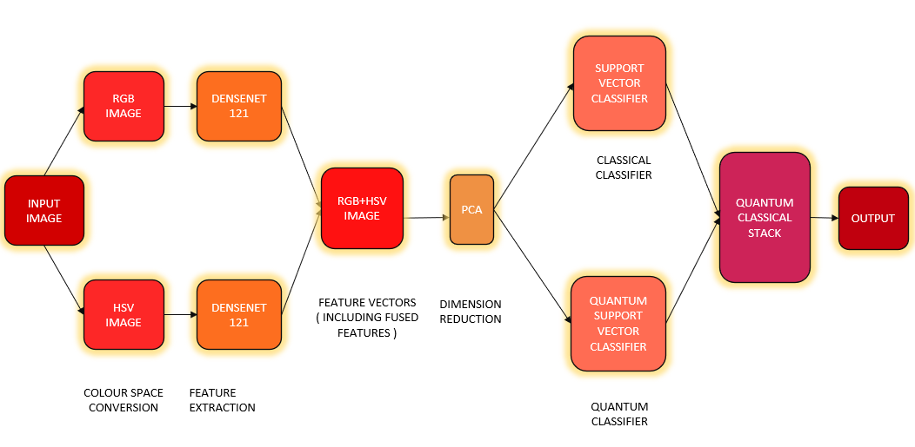

**Fig 2.** Flowchart of Quantum Inspired Binary Classification

**Colour Space Conversion :** Initially, the authors converted the RGB images to HSV colour space. This conversion process allowed for a broader representation of the image data, capturing additional aspects in case of HSV. HSV colour space represents colours based on hue (H), saturation (S), and value (V). In case of 8-bit and 16-bit images, R, G, and B are converted to the floating-point format and scaled to fit the 0 to 1 range.

$V →MAX\left\{R,G,B\right\}$*-(11)*

$S → \left\{\begin{aligned}\frac{V-min⁡\{R,G,B\}}{V} \\ 0\end{aligned} {if V≠0 \atop otherwise}\right.$*- (12)*

$H→\left\{\begin{aligned}{\frac{60\left(G-B\right)}{V-\min\left\{R,G,B\right\}} if V=R \atop 120+\frac{60\left(B-R\right)}{V-\min\left\{R,G,B\right\}} if V=G} \\ {240+\frac{60\left(R-G\right)}{V-\min\left\{R,G,B\right\}} if V=B \atop 0 if R=G=B}\end{aligned} \right.$*- (13)*

If H<0 then H $←$ H + 360. On output $0≤V≤1, 0≤S≤1, 0≤H≤360$

For 8-bit image $V←255V, S←255S, H←H/2$

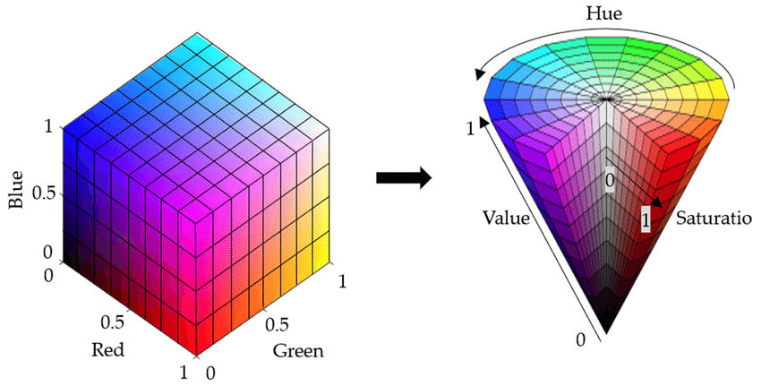

**Fig 3.** RGB to HSV colour space conversion

|  |  |
| --- | --- |
| (a) | (b) |

**Fig 4.** RGB to HSV conversion of a sample image

**Feature Extraction :** DenseNet121 is a variant of the DenseNet architecture, known for its dense connectivity pattern, where each layer receives input from all previous layers in the network. Specifically, DenseNet121 consists of 121 layers organized into four dense blocks, each followed by a transition layer that reduces the feature map size. The network uses a growth rate kkk, which defines the number of output feature maps produced by each layer.

DenseNet121 employs batch normalization and ReLU activation functions after each convolution, with 3x3 convolutions used in the dense blocks. The transition layers consist of 1x1 convolutions, followed by 2x2 average pooling to reduce the spatial dimensions of the feature maps. This architecture significantly improves gradient flow, allowing for efficient training even with deep networks, and promotes feature reuse, reducing the number of parameters compared to traditional convolutional networks.

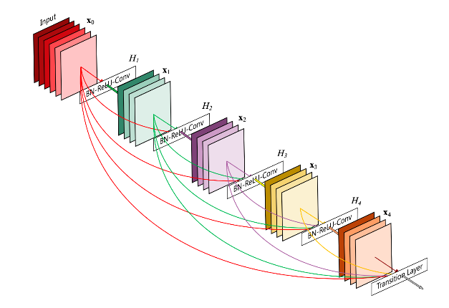

**Fig 5.** DenseNet architecture visual representation.

**Cross Colour Space Feature Fusion:** In this study, after converting the images to RGB and HSV colour spaces, both sets were passed through DenseNet121 to extract feature vectors. Each image produced a feature vector with dimensions 300×1000, reflecting the network's ability to capture high-level, discriminative features. These feature vectors were then averaged to create a unified representation, preserving important information from both color spaces while maintaining the dimensionality of 300×1000.

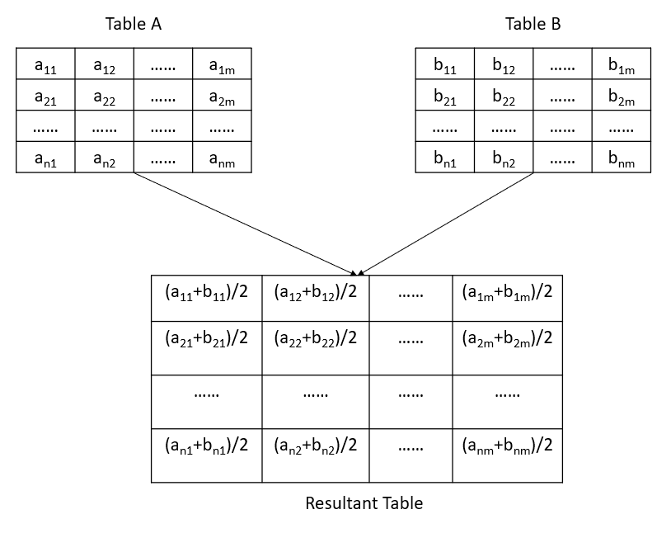

**Fig 6.** Sample calculation of cross-colour space feature ensemble: Table A represents features extracted from the RGB image, and Table B represents features from the HSV image. The Resultant Table shows the element-wise average of the two feature sets.

**Dimension Reduction :** To optimize the extracted feature vector and ensure compatibility with qubit constraints in quantum computing, Principal Component Analysis (PCA) was applied to reduce its dimensionality from 300×1000 to 300×10. PCA is a dimensionality reduction technique that identifies and preserves the most significant variance in the data, transforming it into a smaller set of principal components.

The primary motivation behind applying PCA in this context was to make the feature vector suitable for quantum classifiers, such as the Quantum Support Vector Classifier (QSVC), which require the input data to adhere to specific dimensional constraints imposed by qubit systems. High-dimensional data may not efficiently map to quantum states due to hardware limitations, and reducing the dimensionality ensures that the input can be processed effectively within the qubit framework.

By transforming the feature space into a compact representation:

1. **Compatibility:** PCA ensures that the reduced feature vector aligns with qubit constraints, making it feasible for quantum classification models.
2. **Efficiency:** Lower dimensions reduce the computational overhead and complexity of quantum algorithms.
3. **Retention of Key Information:** Despite dimensionality reduction, PCA preserves the most important patterns and variance in the data, maintaining the quality of features needed for accurate classification.
4. **Noise Reduction:** Less relevant and noisy components are discarded, improving the robustness of the feature vector.

Thus, PCA transformed the original 300×1000 feature matrix into a compact 300×10 representation, balancing dimensionality constraints, quantum hardware requirements, and feature information preservation for subsequent quantum classification tasks.

This feature vector is used for classification using two distinct methods: the classical Support Vector Classifier (SVC) and the Quantum Support Vector Classifier (QSVC). The mathematical foundation of these methods is discussed below.

**Support Vector Classifier :** The Support Vector Classifier (SVC) is a supervised machine learning method that performs classification by constructing a decision boundary or hyperplane that best separates the data points belonging to different classes.

Given a dataset (xi, yi), where xi∈Rn represents the feature vector and 𝑦𝑖∈{−1,1} denotes the class label, SVC seeks a hyperplane defined by: $w^{T}+b=0$, where w is the weight vector and b is the bias term. The SVC aims to find (w,b) by following the optimization problem,

$$\min_{w,b,ξ}{\frac{1}{2}{∥w∥}^{2}+C\sum_{i=1}^{m}{ξ_{i } -(14)}}$$

subject to, $y_{i}\left(w^{T}+b\right)≥1-ζ_{i}$ and $ζ_{i}≥0$ for $i=1,2,3,…,m$, where, $ζ_{i}$ is a slack variable to allow for misclassification in non-separable data. And $C$ is the regularization parameter controlling the trade-off between maximizing the margin and minimizing classification error.

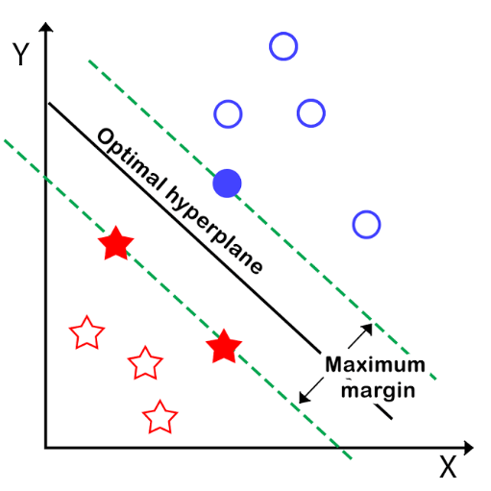

**Fig 7.** Support Vector Classifier

Moreover, the SVC's ability to handle non-linearly separable data through kernel functions further supports its use in this project. For this classification task, a linear kernel was employed as the reduced feature vector dimensions (300x10) are already optimized, and a linear decision boundary provides an effective and computationally efficient solution.

By leveraging SVC as a classical classifier, the extracted features from DenseNet121 are effectively utilized to distinguish between the two classes, setting a strong foundation for further processing using the meta-classifier and YOLO models in subsequent steps.

**Quantum Support Vector Classifier :** The Quantum Support Vector Classifier (QSVC) represents a quantum-enhanced counterpart to the classical Support Vector Classifier (SVC), leveraging the power of quantum computing to address complex and high-dimensional classification problems. Unlike traditional SVC, which operates in classical computational space, QSVC utilizes the principles of quantum mechanics to map data into a high-dimensional quantum Hilbert space. This quantum approach allows for improved handling of non-linearly separable data and complex feature spaces, making QSVC particularly promising for tasks that require greater computational efficiency and accuracy.

QSVC employs a quantum kernel that performs the kernel trick in quantum space. The kernel trick, as in classical SVC, enables QSVC to efficiently project input features into a higher-dimensional space without explicitly calculating the feature mapping. However, in QSVC, this mapping occurs in a quantum state space, which allows for exponentially large representations of data compared to classical methods. This quantum advantage can lead to improved classification performance, particularly when the data's complexity exceeds the capabilities of classical algorithms.

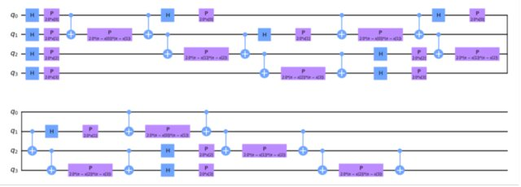

**Fig 8.** ZZFeatureMap Quantum Circuit Illustration.

In this implementation, QSVC uses the ZZFeatureMap, a popular quantum feature encoding technique, to map classical input data into quantum states. The ZZFeatureMap includes specific quantum gates that encode the data points into a quantum circuit, allowing quantum interactions to capture the relationships between input features effectively. Key aspects of the feature map include:

1. **Two circuit repetitions**: The repeated application of the feature map layers improves the expressivity of the quantum model by allowing the circuit to capture more complex correlations in the input data.
2. **Linear qubit entanglement**: The entanglement between qubits ensures that the quantum system can model feature interactions effectively, enabling richer feature representations and improving the classifier's ability to distinguish between classes.

The ZZFeatureMap with its tunable repetitions and qubit entanglement structure enhances the QSVC's capability to learn and generalize across complex datasets, making it well-suited for high-dimensional medical imaging tasks such as histopathological image classification.

By integrating QSVC with quantum feature encoding and leveraging quantum entanglement, the project explores cutting-edge quantum machine learning techniques to address high-dimensional histopathological image classification tasks, highlighting the future potential of quantum-enhanced algorithms.

**Quantum Classical Stack Ensemble :** In the quantum-classical stack ensemble approach, the goal is to leverage the predictions from both classical and quantum models—Support Vector Classifier (SVC) and Quantum Support Vector Classifier (QSVC)—to improve the overall performance of the classifier. Here's a detailed explanation of this part of the process:

After training the SVC and QSVC models using the reduced feature vector (which was obtained through DenseNet121 feature extraction and Principal Component Analysis (PCA)), both classifiers generate predictions for the training dataset. These predictions are essentially the output class labels predicted by the SVC and QSVC models. Each of these classifiers provides a prediction for each data point in the training set.

The key step in the quantum-classical stack ensemble is to combine the outputs of these two models (SVC and QSVC) with the original feature set. This is done by adding the prediction results from both models as additional features to the original dataset. Mathematically, we can describe this process as follows:

1. Let X represent the original feature matrix of the training data with dimension (m×n), where m is the number of samples and n is the number of features.
2. Let $y_{SVC}$ ​ be the prediction output of the SVC model, which is a vector of size (m×1), containing the predicted labels for the training set.
3. Let $y_{QSVC}$ be the prediction output of the QSVC model, which is also a vector of size (m×1), containing the predicted labels from the quantum model.

The new feature set, $X_{meta}$ ​, can be constructed by concatenating the original feature matrix X with the prediction outputs from both SVC and QSVC:

$X_{meta}=\left\langle X | y_{SVC} | y_{QSVC}\right\rangle$---(15)

This augmented feature set now contains the original features of the data, as well as the predictions from both the classical and quantum models. The idea behind this step is to allow the meta-classifier, which will be trained in the next step, to learn how to combine the information from both SVC and QSVC to make the final prediction.

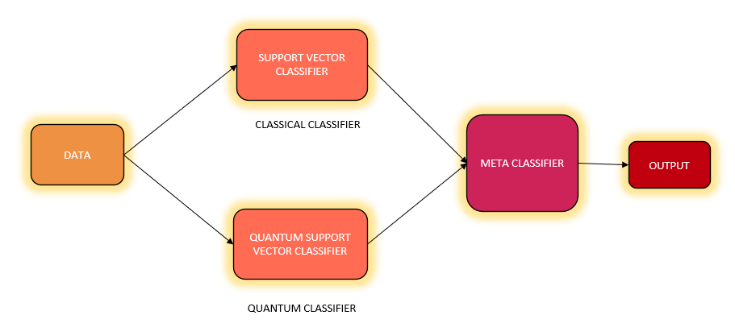

**Fig 9.** Quantum Classical Stack Ensemble

The meta-classifier, which is typically a Logistic Regression model. The logistic regression model is trained on this new augmented dataset, where the goal is to learn the optimal coefficients for the features. This meta-classifier combines the classical and quantum predictions, learning how to optimally integrate the two sources of information. The strength of this approach lies in its ability to leverage the complementary strengths of classical and quantum models, ensuring that the final prediction benefits from both the classical efficiency of the SVC and the potential higher-dimensional power of the QSVC.

* 1. **Vision Based Subclass Prediction (Stage II)**

In this system, a Quantum-Inspired Binary Classification approach is employed to categorize an image into one of two broad categories: "benign" or "malignant." This initial classification is crucial for determining the subsequent processing steps. Based on whether the image is classified as "benign" or "malignant," it is then fed into a custom YOLOv8 model tailored to handle each category. For the "benign" category, the image is processed by a YOLOv8 model that has been trained specifically to detect benign features. Conversely, for the "malignant" category, the image is directed to a different YOLOv8 model trained to detect signs of malignancy. The model then predicts a subclass for the image, which represents the final disease prediction.

YOLOv8 is an advanced object detection, classification or segmentation model that excels in real-time processing and high accuracy. The process begins with the quantum-inspired binary classification, where the image is first classified as either "benign" or "malignant." Depending on this classification, the image is then processed by the appropriate YOLOv8 model. The "benign" classification directs the image to a YOLOv8 model trained on benign images, while the "malignant" classification sends it to a model trained on malignant images. The model is trained to detect not just the presence of disease but to further classify the type or stage of the disease.

1. The subclass under benign category are –

Adenoma, Fibroadenoma, Phyllodes Tumor, Tubular Adenoma.

1. The subclass under malignant category are –

Ductal Carcinoma, Papillary Carcinoma, Mucinous Carcinoma, Tubular Carcinoma.

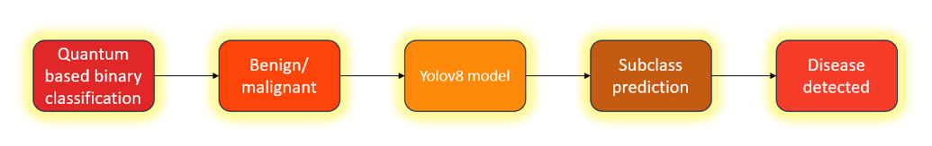

**Fig 10.** Flowchart of Vision Based Subclass Prediction

**Training YOLOv8 :** The YOLOv8 classification model was trained using the following configuration:

* Platform: Tesla T4 GPU (available on Google Colaboratory and Kaggle Notebook)
* Dataset: 300 images
* Epochs: 50 epochs
* Batch Size: 16
* Input Image Size: 128x128 pixels
* Learning Rate: 0.01

Additionally, advanced augmentation techniques, including mosaic augmentation, are applied during training, boosting the model's robustness to variations in input data. YOLOv8 also integrates CSPNet (Cross-Stage Partial Networks), which optimizes feature extraction by reducing computational complexity without sacrificing performance. The refined loss function further improves the model by balancing classification and localization losses, leading to more accurate object detection. Finally, YOLOv8 strikes a balance between speed and accuracy, ensuring real-time processing capabilities without compromising detection precision, making it particularly well-suited for time-sensitive applications like medical image analysis.

**4.6. Metrics Quantification**

The plot in Fig 11 clearly demonstrates the effectiveness of combining color spaces for improving the performance of classification models. Initially, the analysis was conducted using individual color spaces, namely RGB and HSV, and then with an ensemble of RGB and HSV. Two models were evaluated: Support Vector Classifier (SVC) and Quantum-Inspired Support Vector Classifier (QSVC).

**Fig 11.** Plot showing the result of colour space ensembling

For the RGB color space, the SVC achieved an accuracy of 0.7129, while the QSVC slightly outperformed it with an accuracy of 0.7614. Similarly, in the HSV color space, the SVC achieved an accuracy of 0.8055, and QSVC further improved this to 0.8165. The most significant improvement was observed when RGB and HSV color spaces were combined. The ensemble approach leveraged the strengths of both color spaces, resulting in a remarkable increase in accuracy. The SVC achieved an accuracy of 0.9722, and the QSVC reached a near-perfect accuracy of 0.9908. This demonstrates that the fusion of features from multiple color spaces allows the model to capture more comprehensive information, leading to significantly better predictions.

Table 1 demonstrates how the quantum-classical stack ensemble improves results by combining the strengths of classical and quantum models. In this approach, both the classical and quantum models independently make predictions, capturing unique patterns and features within the data. These individual predictions are then combined using a stacking ensemble method, where a meta-classifier is employed to learn from and optimize the combined predictions. The meta-classifier effectively identifies and weighs the most accurate contributions from each model, resulting in enhanced overall performance. This stacking approach leverages the diversity and complementary strengths of classical and quantum predictions, leading to a more robust and accurate classification outcome.

|  |  |  |  |  |
| --- | --- | --- | --- | --- |
| **Model Name** | **Accuracy** | **Precision** | **Recall** | **F1 Score** |
| SVC | 97.22% | 96.80% | 97.10% | 96.95% |
| QSVC | 99.08% | 99.10% | 98.95% | 99.02% |
| Stack Model | 99.79% | 99.80% | 99.75% | 99.77% |

**Table 1.** Table showing the result of Quantum Classical Stack ensemble

Figures 12 and 13 demonstrate the mAP@0.5 and mAP@0.5:0.95 metrics, respectively, for two different YOLOv8 models. These metrics are crucial for evaluating the performance of object detection models. mAP@0.5 measures the mean Average Precision at a single Intersection over Union (IoU) threshold of 0.5, providing an indication of the model's ability to detect objects accurately. On the other hand, mAP@0.5:0.95 calculates the mean Average Precision across multiple IoU thresholds ranging from 0.5 to 0.95, in increments of 0.05, offering a more comprehensive assessment of the model's precision across varying levels of localization strictness. Together, these metrics provide a detailed evaluation of the model's detection capabilities, with mAP@0.5 highlighting the overall detection accuracy and mAP@0.5:0.95 assessing both precision and robustness in handling object localization challenges. Comparing these metrics enables a deeper understanding of model performance under different detection scenarios.

**Fig 12.** Plot showing the result of YOLOv8 trained on benign dataset

**Fig 13.** Plot showing the result of YOLOv8 trained on malignant dataset

Both YOLO models achieve around 90% accuracy, which is highly sufficient for reliable and efficient object detection in the given application.

1. **Implementation-Level Research**
   1. **Doctor Recommendation Algorithm Design**

**Geolocation based Filtering :** The first stage of the system involves identifying doctors who are geographically close to the user. Upon entering a location, the system uses geocoding (e.g., via Nominatim) to extract the corresponding latitude and longitude coordinates. The geodesic distance between the user and each doctor is then computed using the haversine formula as Eq 6.

$d=2r arcsin\left(\sqrt{\sin^{2}\left(\frac{∆∅}{2}\right)+cos\left(∅_{1}\right)cos\left(∅_{2}\right)\sin^{2}\left(\frac{∆λ}{2}\right)}\right)$---(16)

Where, $∅_{1}, ∅_{2}$ are the latitudes of the user and the doctor, $∆∅=∅_{2}-∅_{1},$ where, $∅_{1}, ∅_{2}$ are the latitudes of the user and the doctor. $∆λ=λ_{2}-λ_{1}$, where, $λ_{1}, λ_{2}$ are the longitudes, and *r* is the Earth’s radius.

**Temporal Matching of Availability :** To ensure that the recommended doctors are actually available at the requested time, the system checks whether the user’s preferred date and time align with the doctor’s schedule. The date is first converted into a weekday (e.g., Monday, Tuesday), and then the system compares the user’s selected time slot with the doctor’s available hours on that day. If there is any overlap between the user’s time and the doctor’s availability, the doctor is considered a valid match.

**Multi-Objective Optimization Using Pareto Front:** Once a filtered set of doctors is available, the next step is to rank them based on multiple conflicting objectives:

* Minimize distance from the user $(f_{1})$
* Maximize doctor rating $(f_{2})$
* Maximize years of experience $(f_{3})$

This is inherently a multi-objective optimization problem, where improving one objective might degrade another. Instead of combining objectives into a single scalar score (which would require arbitrary weightings), the system identifies the Pareto optimal set using Non-Dominated Sorting Genetic Algorithm II (NSGA-II).

The Pareto front is the set of all non-dominated solutions — no solution in this set can be said to be strictly better than another without making a trade-off. For example, one doctor may be closer but have lower experience, while another may have a higher rating but be farther away. The Pareto front visually forms the boundary of feasible trade-offs.

The algorithm proceeds through a sequence of evolutionary operations, blending classical genetic algorithm techniques with multi-objective-specific mechanisms:

* Step 1: An initial set of candidate solutions is generated randomly. Each solution is represented by a chromosome encoding decision variables relevant to the problem.
* Step 2: Each individual is evaluated based on multiple objective functions. These evaluations determine how well a solution performs with respect to each goal.
* Step 3: The population is organized into different fronts based on Pareto dominance. The first front contains the best solutions, while subsequent fronts represent progressively less optimal ones in terms of trade-offs.
* Step 4: Within each front, crowding distance is calculated. This ensures that the selected solutions are not only optimal but also spread out across the objective space, preventing clustering.
* Step 5: NSGA-II uses binary tournament selection, where two individuals are randomly selected and compared based on their front rank. If they belong to the same front, the one with the larger crowding distance is chosen to promote diversity.
* Step 6: Selected parents undergo crossover to exchange genetic material and produce new offspring. Mutation introduces small random alterations in some solutions, enhancing exploration of the solution space and preventing premature convergence.
* Step 7: The current population and newly generated offspring are combined. A new population is then formed by selecting the best individuals based on their dominance rank and crowding distance, ensuring both quality and diversity.
* Step 8: The algorithm repeats the above steps until a predefined condition is met, such as a fixed number of generations or convergence of the population. The final population represents the Pareto-optimal front, providing multiple balanced solutions for decision-making.

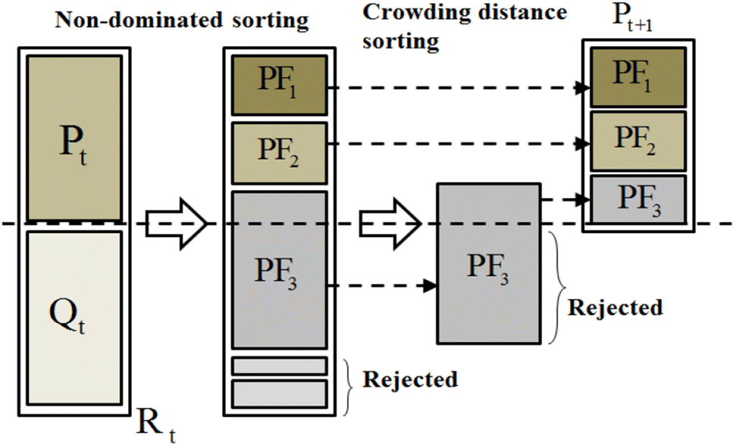

**Fig 14.** NSGA-II Algorithm

* 1. **Agentic Chatbot Design**

**What is Agentic AI :** Agentic AI refers to systems capable of autonomously managing multi-step tasks by reasoning over user inputs, invoking external tools, and maintaining awareness of their role and boundaries. Unlike standard language models that respond passively to prompts, agentic systems actively decide what actions to take, what tools to call, and whether a request is even appropriate for the system’s domain.

In our context—medical assistance—this agentic behavior is crucial. A general-purpose LLM might hallucinate information or respond to irrelevant queries, which can be dangerous. Our agent is designed to restrict itself to healthcare-related tasks only, ensuring domain fidelity and safety.

**Why use an Agent instead of just an LLM :** Although LLMs like LLaMA3-70B-Versatile are powerful, using them without structured oversight can lead to unbounded outputs. Medical applications require precision, reliability, and controlled interaction. By placing the LLM inside an agentic framework, we ensure it only responds to valid, medical-domain prompts, leveraging specialized tools where necessary.

**Agentic Flow Design :** The architecture of our agentic chatbot system is designed to handle complex medical-domain tasks using a modular, controlled, and tool-augmented reasoning loop. At its core, the agent acts as an orchestrator that dynamically routes input through different components—LLMs and specialized tools—based on intent, task type, and domain constraints. Below is a breakdown of the flow, reflected in the system diagram as in Fig 15.

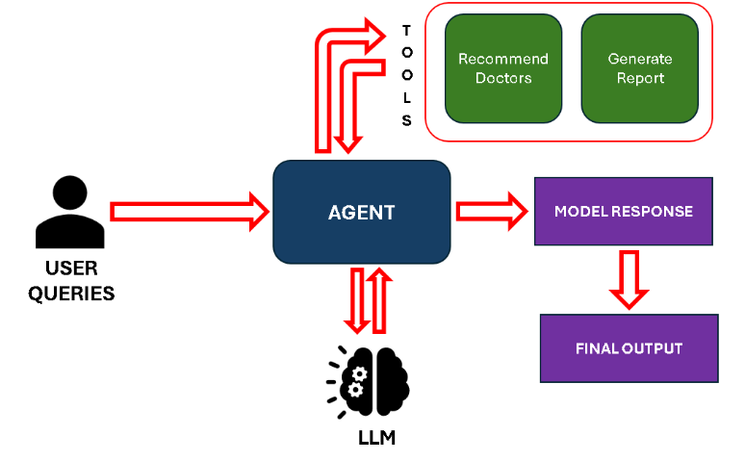

**Fig 15.** Agentic Flow Design

* User inputs—typically in natural language—are first passed to the agent. The input may range from symptom descriptions and diagnostic queries to requests for structured documentation. Before taking any action, the agent performs task inference, where the agent determines whether the user’s query aligns with

1. Tool-based invocation (e.g., recommend doctor, generate report)
2. General LLM consultation
3. Domain-inappropriate requests (which are blocked)

This initial processing enables the agent to maintain task specificity and role boundaries.

* Once the task type is inferred, the agent proceeds to route the request accordingly. Tool call is handled as follows:

1. For doctor recommendations, the agent parses required information like preferred location, date, time etc to filter availability of doctors from the database.
2. For report generation, the agent fetches the report from the database.

* For any general query, the agent invokes the LLaMA3-70B-Versatile model hosted on Groq for LLM-based reasoning.
* After receiving responses from the appropriate sub-component (tool or LLM), the agent aggregates data if multiple tools are used in sequence, applies formatting rules to ensure user-friendly readability (e.g., markdown, structured tables, or bullet points).

The agentic chatbot design blends the strengths of LLMs with the structure of domain-specific tools, creating a robust and scalable framework for healthcare interactions. By using the agent as a reasoning hub, the system not only answers medical queries effectively but also maintains clear boundaries—ensuring safety, relevance, and precision.

1. **System Design**

The following image depicts the system design, illustrating the workflow of our web application from user input to disease detection and report delivery.

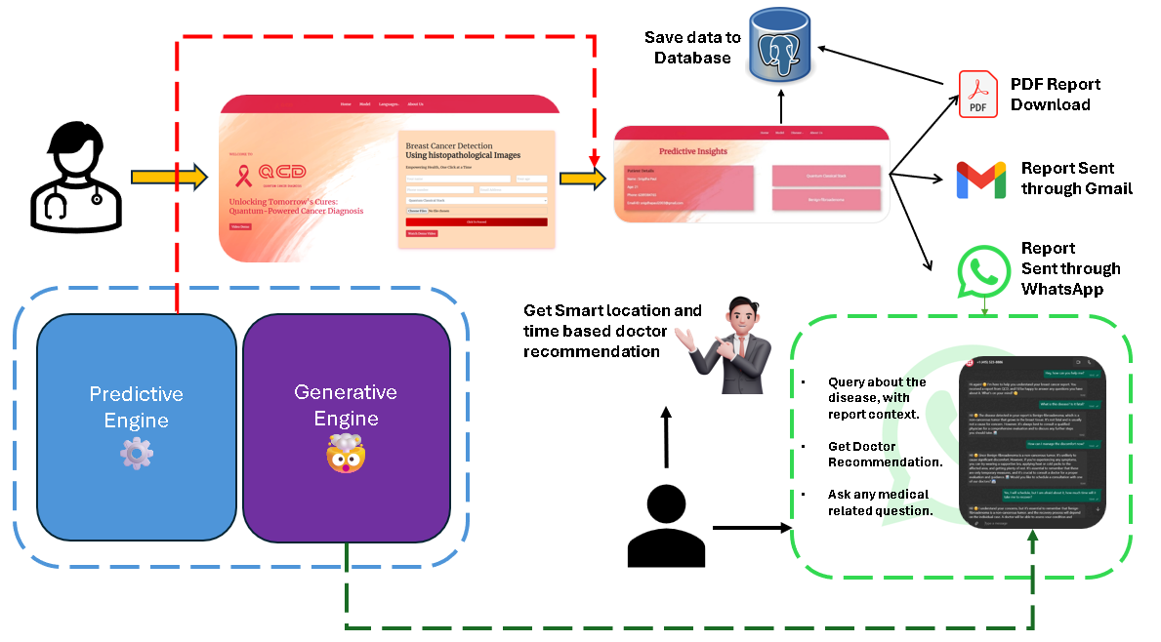

**Fig 16.** System Design

1. **Website Inference**

Our web application features a simple and intuitive user interface designed for ease of use by all types of users. For clinical professionals, the application provides a straightforward form where they can easily upload patient details and histopathological images. Additionally, users can select the desired model for analysis with just a few clicks. By filling out the form, clinical professionals can quickly and efficiently generate results, ensuring a seamless experience with minimal complexity.

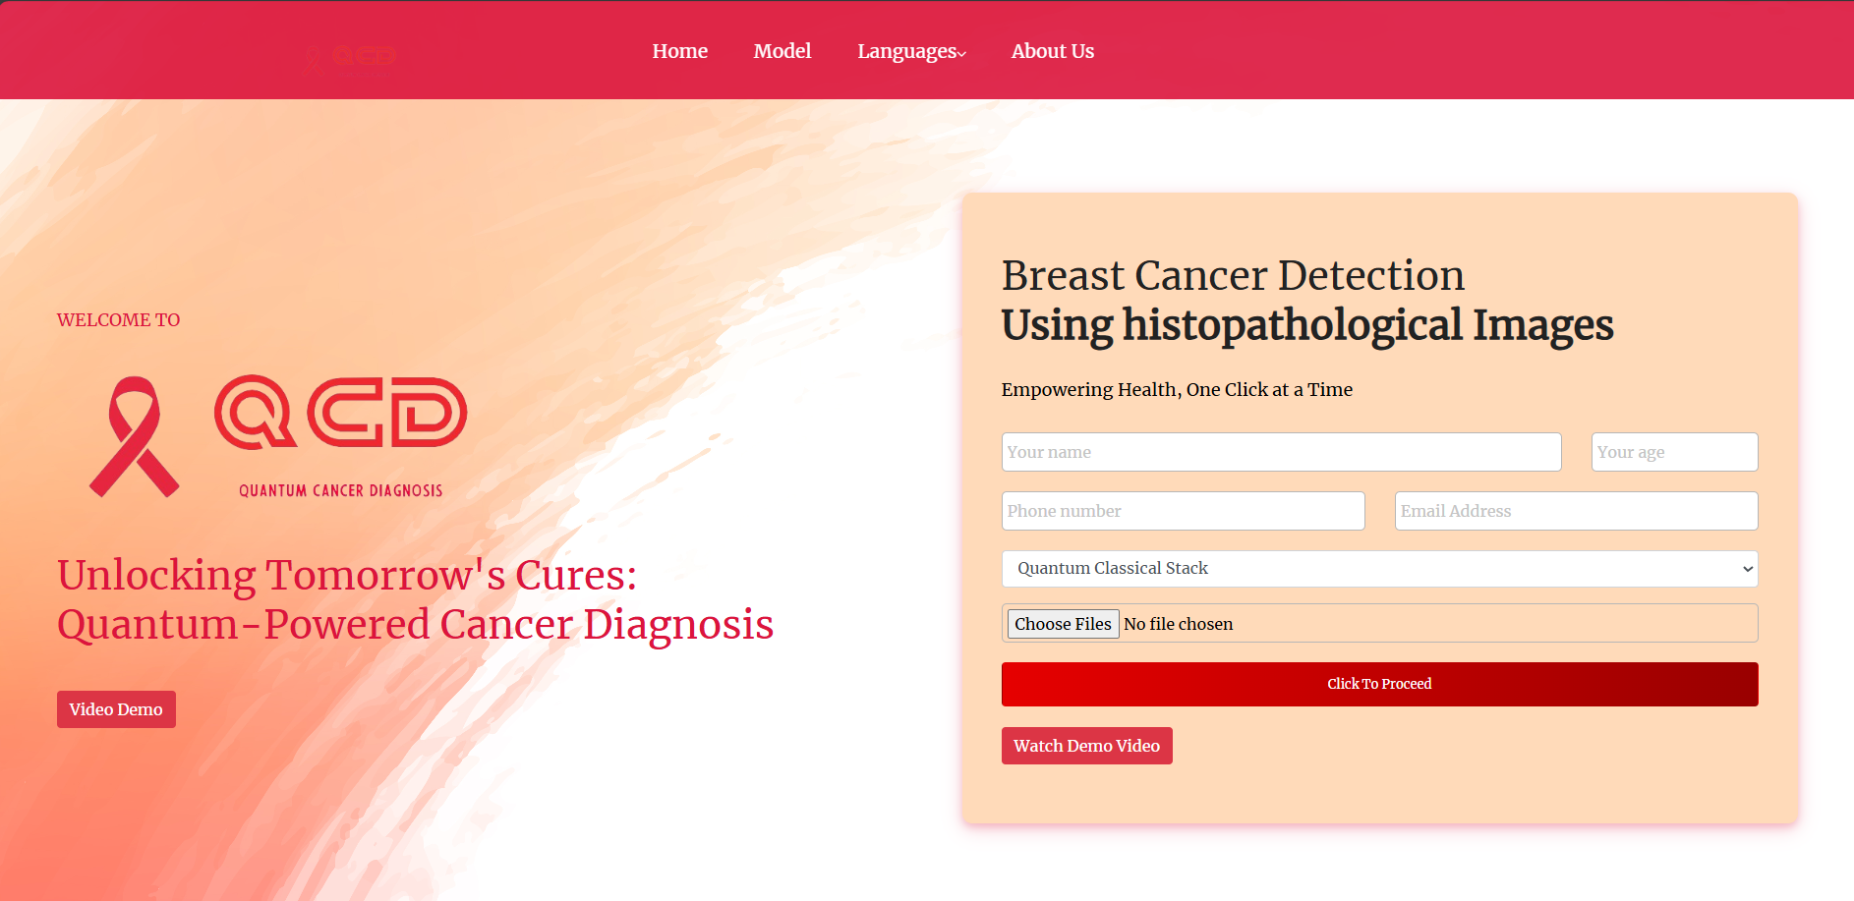

**Fig 17.** The front page of our Web Application

The prediction page displays the patient's details, the model used, and the detected disease, along with the probability for each disease predicted by the YOLOv8 model. It also includes two action buttons for clinical professionals: one to generate the report and another to update the information in the database. This streamlined design ensures quick access to important results and facilitates seamless workflow management.

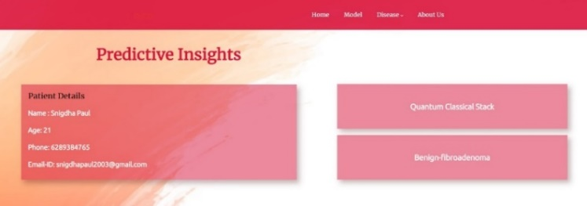

**Fig 18.** The prediction page of our Web Application

Fig 19 to 22 are sample outputs of benign images from the web application, displaying the predicted classes along with their associated probabilities.

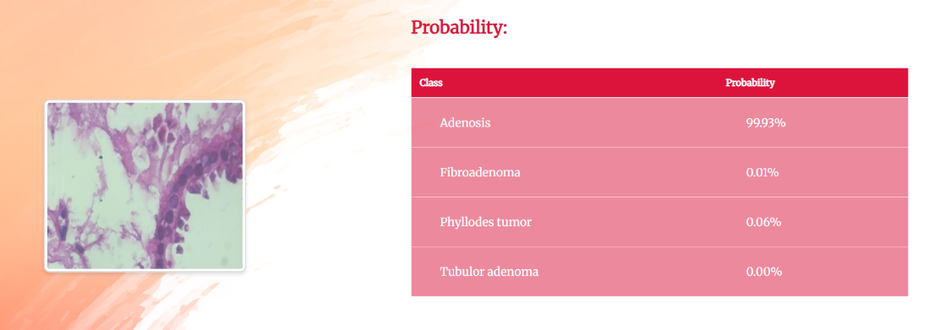

**Fig 19.** Output of Benign-Adenosis prediction

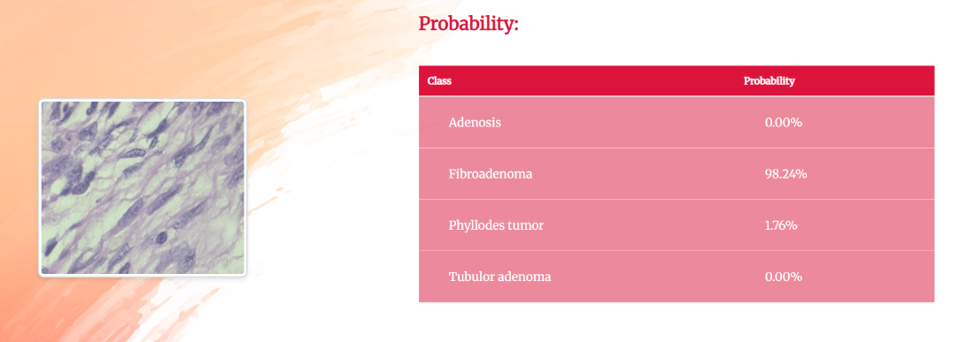

**Fig 20.** Output of Benign-Fibroadenoma prediction

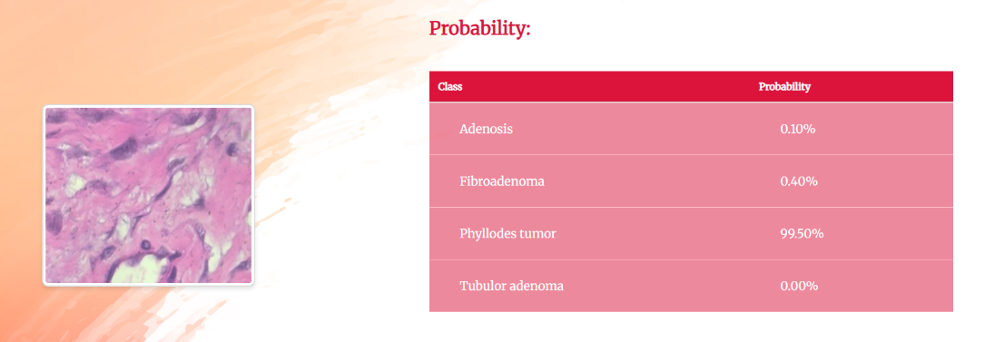

**Fig 21.** Output of Benign-Phyllodes Tumor prediction

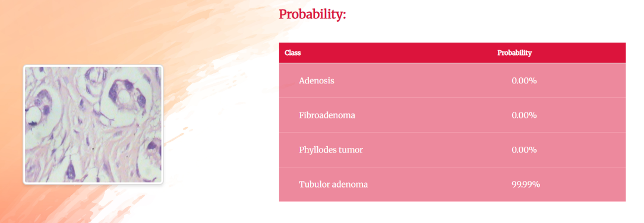

**Fig 22.** Output of Benign-Tubulor Adenoma prediction

Fig 23 to 26 are sample outputs of benign images from the web application, displaying the predicted classes along with their associated probabilities.

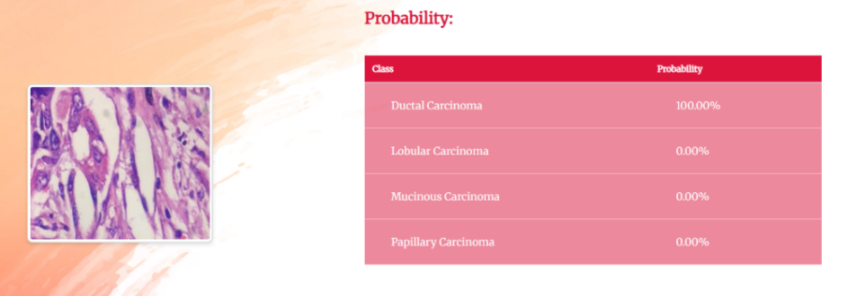

**Fig 23.** Output of Malignant-Ductal Carcinoma prediction

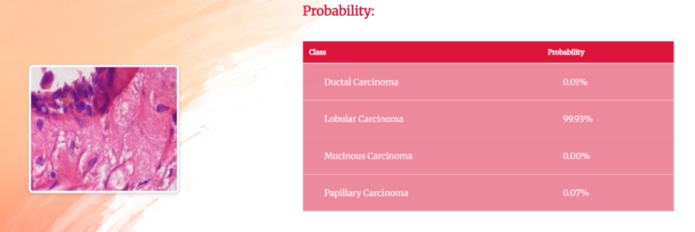

**Fig 24.** Output of Malignant-Lobular Carcinoma prediction

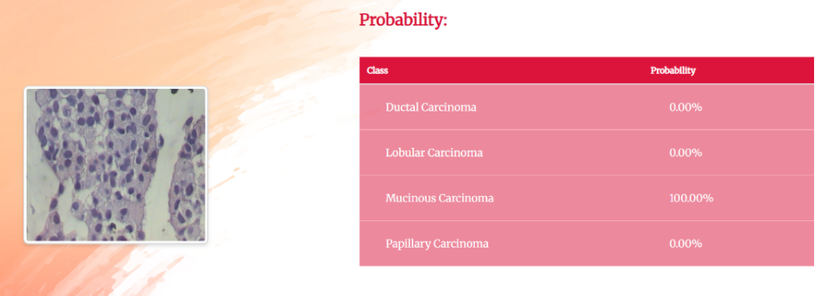

**Fig 25.** Output of Malignant-Mucinous Carcinoma prediction

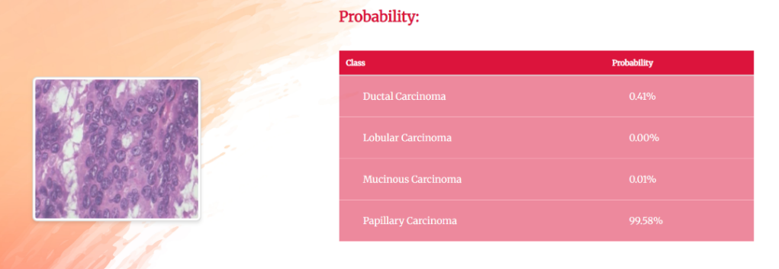

**Fig 26.** Output of Malignant-Papillary Carcinoma prediction

1. **Website Features**

**8.1. Report Generation**

The report generation feature allows clinical professionals to easily create detailed reports in PDF format. Once the prediction results are generated, the system automatically compiles the patient's details, the model used, the detected disease, and the probabilities for each predicted condition into a structured, professional report. This PDF report can be easily accessed, downloaded, or printed, providing a comprehensive summary of the analysis for further review or documentation. The straightforward process ensures that healthcare professionals can efficiently generate and share accurate, formatted reports with minimal effort.

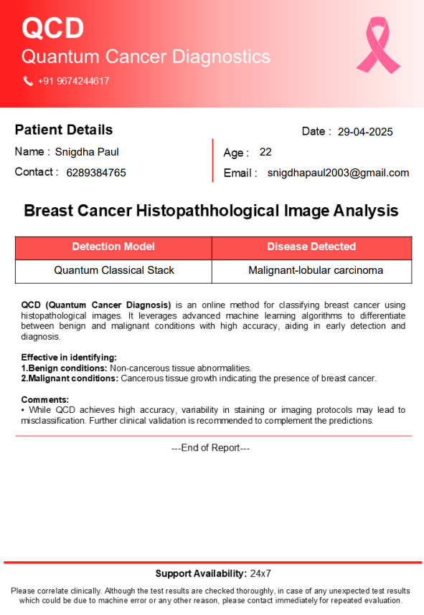

**Fig 27.** Generated Report in PDF format

**8.2. Mail to the User**

The email sent to the user will contain a summary of the analysis results, including the patient's details, the model used, and the detected disease along with the probabilities for each predicted condition. It will also provide an attachment to download the generated PDF report for further review. The email will be professionally worded to ensure clarity, offering the user easy access to the results and the option to take further actions, such as updating the database or generating additional reports. The email ensures that users are promptly informed of the outcomes and can quickly access important data related to the analysis.

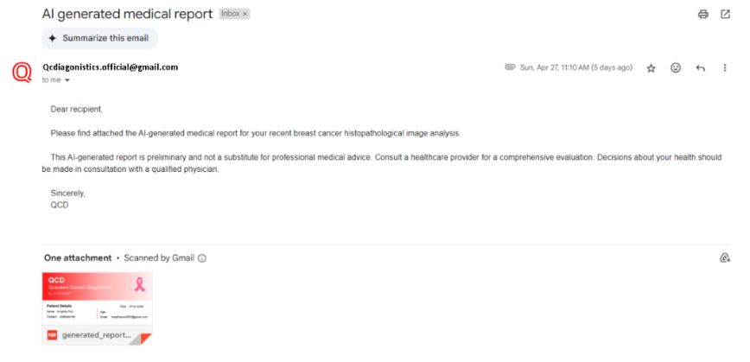

**Fig 28.** Mail sent to the User

**8.3. Database Management**

In our system, a structured relational database was implemented to manage patient information efficiently, supporting fast retrieval and scalability. Each entry in the table corresponds to a unique patient record, identified by a primary key serial_number, and includes essential attributes such as name, age, phone number, email, model type, predicted disease class, and a reference to the associated diagnostic image. The database serves as the backbone for storing both input data and the AI model’s output, enabling downstream functionalities like report generation and doctor recommendation. Proper normalization ensures data integrity while indexed fields allow for quick search and access across different modules in the pipeline.

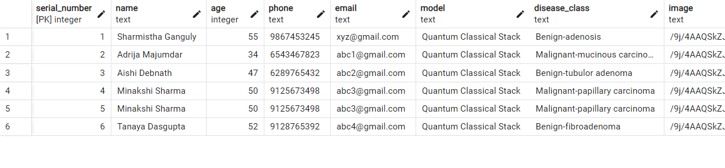

**Fig 29.** Relational Database Table Design

**8.4. WhatsApp based Medical Assistant**

The agentic medical chatbot as explained in section 5.2 is seamlessly integrated with WhatsApp using Twilio's messaging API, enabling users to interact with the system through a familiar and widely-used platform. This integration allows users to report symptoms, receive doctor recommendations, and access generated medical reports directly via WhatsApp, ensuring convenience, accessibility, and timely assistance in their healthcare journey.

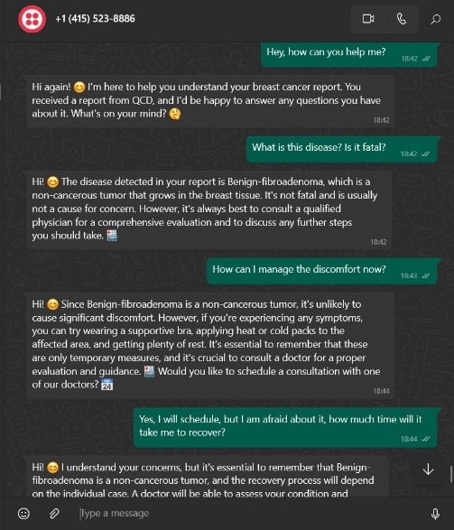

**Fig 30.** Medical AI Assistant through WhatsApp

The AI-powered medical assistant in this chat provides several key benefits to help patients manage their health concerns:

1. **Clear Explanation of Medical Reports**: The assistant interprets complex medical terms from the patient's breast cancer report and provides a simplified explanation. In this case, it explains that "Benign-adenosis" is a non-cancerous tumor and reassures the patient that it is a small lump and it is not fatal, as shown in Fig 31.

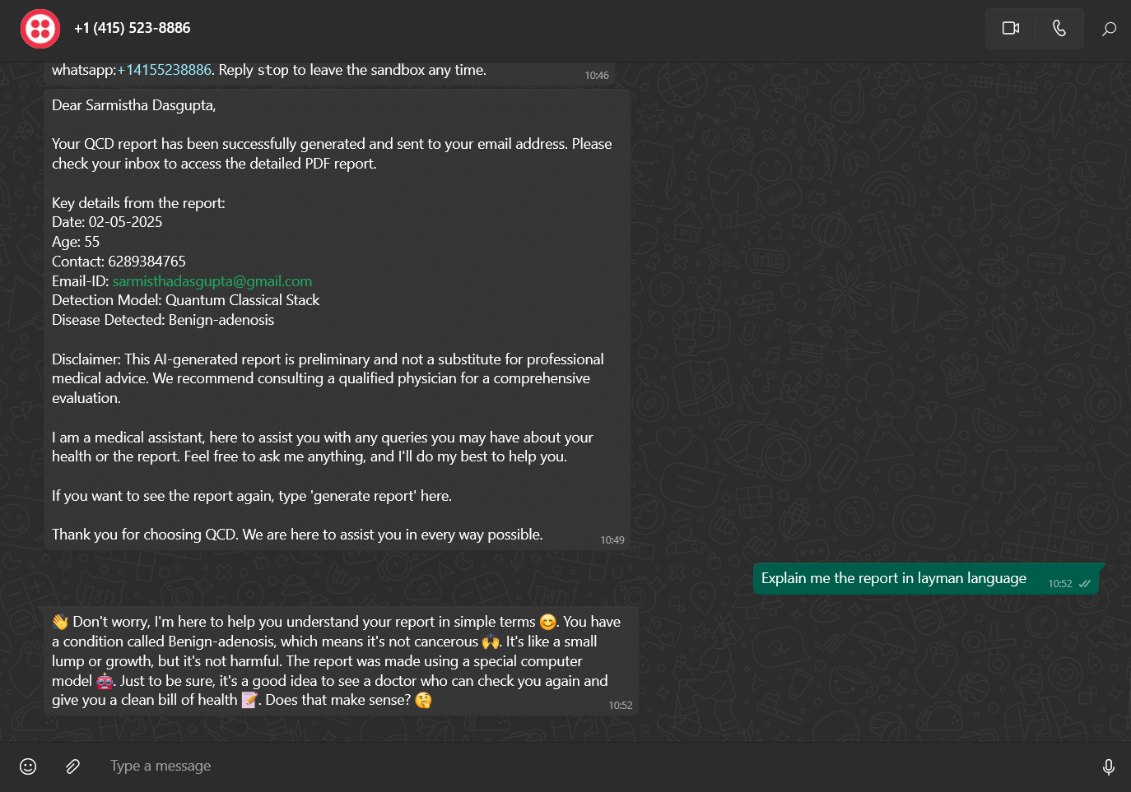

**Fig 31.** Explanation of Report by Agent

1. **Addressing Patient Concerns**: By answering specific questions, such as whether the disease is fatal or how to manage discomfort, the assistant reduces anxiety and ensures the patient is well-informed.



**Fig 32.** Addressing patient concerns by the agent

1. **Doctor Recommendation**: It emphasizes the importance of consulting a doctor for a comprehensive evaluation and proper treatment, ensuring that the patient takes appropriate medical action. It recommends doctors based on recommend doctors tool call and encourage users to book an appointment by telephone number.

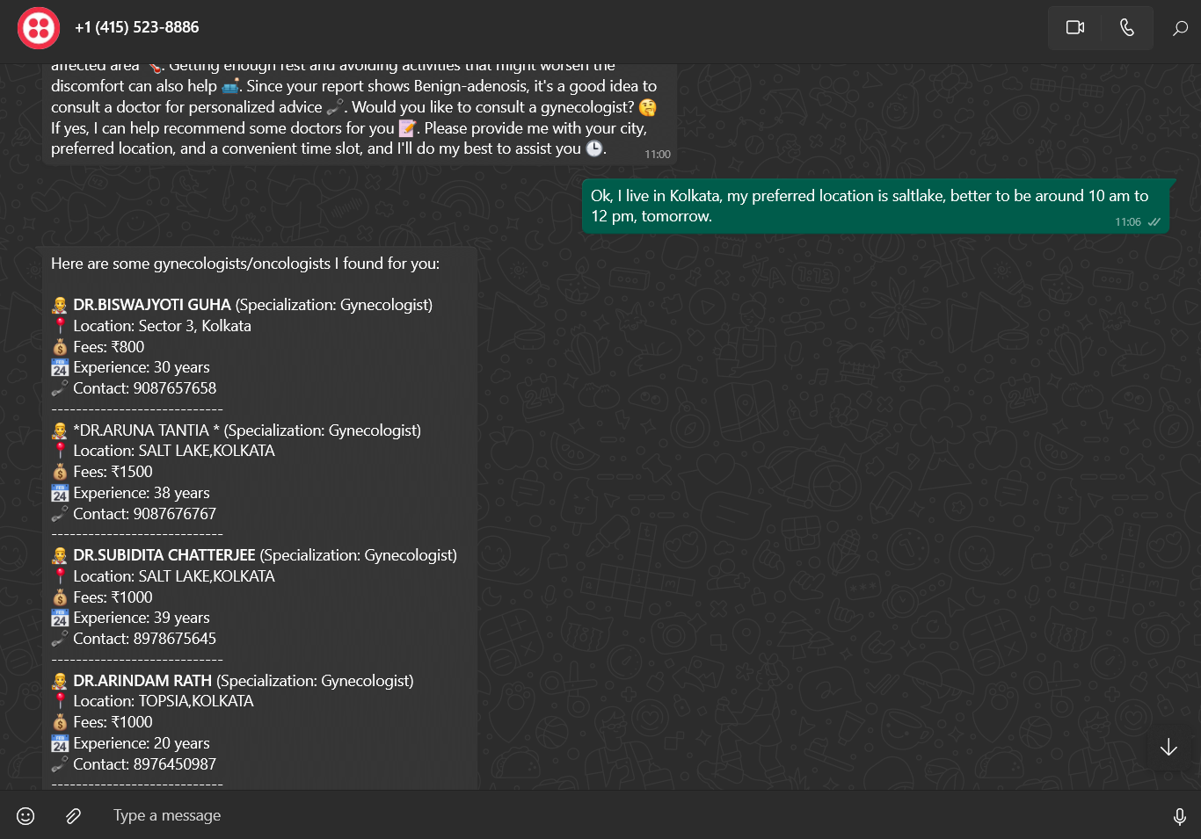

**Fig 33.** Doctor Recommendation by the agent

By combining information, practical advice, and emotional support, the assistant empowers patients to take proactive steps toward managing their health while preparing for further medical care.

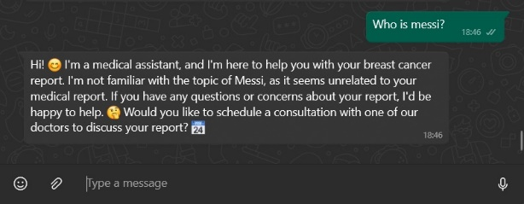

**Fig 34.** Medical AI Assistant prohibiting non-medical chats

The AI medical assistant effectively prohibits non-medical chat by redirecting irrelevant questions back to its primary purpose—providing healthcare guidance. It maintains professionalism by politely stating its limitations and encouraging the user to focus on medical concerns or scheduling consultations.

**8.5. Multilingual Web Application**

To ensure inclusivity and enhance user accessibility across diverse linguistic groups, the web application has been developed with multilingual support, offering interfaces in English, Hindi, and Bengali. This design choice addresses the linguistic diversity of the Indian population, enabling users from different regions to interact with the system in their native or preferred language.

|  |  |
| --- | --- |
| (a) | (b) |

**Fig 35.** Multilingual Web Application

1. **Conclusion**

This project holds significant importance within the Indian medical landscape, where access to timely and accurate diagnostics remains a challenge, particularly in rural and underserved regions. By integrating AI-driven tools such as YOLOv8 for medical image analysis and quantum-inspired classifiers for robust disease prediction, the system effectively addresses the need for affordable and scalable healthcare solutions. In a country facing a high patient-to-doctor ratio and limited diagnostic infrastructure, this technology empowers healthcare professionals with rapid, accurate insights that streamline clinical decision-making and improve patient outcomes.

The platform supports doctor recommendation services accessible via both a web interface and WhatsApp, ensuring broad reach and usability. By leveraging WhatsApp—a widely adopted communication tool—the system provides a familiar and easily accessible interface for patients to interact with the AI assistant, receive diagnostic feedback, and get connected to appropriate medical professionals. Furthermore, the system is multilingual, supporting English, Hindi, and Bengali, thereby catering to a linguistically diverse population and enhancing accessibility for users across different regions.

This inclusive approach ensures that the solution can effectively bridge the urban-rural healthcare divide, providing early detection capabilities and medical guidance even in areas with limited clinical resources.

Looking forward, the project has strong potential for further expansion. Enhancing its medical knowledge base with region-specific datasets will improve accuracy and relevance. Additionally, extending support for more regional languages and integrating telemedicine capabilities can further strengthen its role in India’s digital healthcare ecosystem. With the right partnerships—particularly with government health initiatives—this platform could play a critical role in advancing equitable, technology-enabled healthcare for all segments of the Indian population.

1. **References**
2. International Agency for Research on Cancer. (2025, February). Breast cancer cases and deaths are projected to rise globally. World Health Organization. https://www.iarc.who.int/wp-content/uploads/2025/02/pr361_E.pdf​
3. Mallick, S., Paul, S., & Sen, A. (2024). A Novel Approach to Breast Cancer Histopathological Image Classification Using Cross-Colour Space Feature Fusion and Quantum-Classical Stack Ensemble Method.
4. Shen, D., Wu, G., & Suk, H. I. (2017). Deep Learning in Medical Image Analysis. Annual Review of Biomedical Engineering, 19, 221–248.
5. Das, R., Kaur, K., & Walia, E. (2022). Feature Generalization for Breast Cancer Detection in Histopathological Images. Interdisciplinary Sciences – Computational Life Sciences, 14(2), 566–581.
6. Anurag, A., Das, A., Dewan, J. H., Das, R., Jha, G. K., & Thepade, S. D. (2022). Local Attention-Based Descriptor Definition using Vision Transformer for Breast Cancer Identi-fication. International Journal of Engineering Trends and Technology, 70(12), 317–327.
7. Li, X., & Plataniotis, K. N. (2015). Color model comparative analysis for breast cancer di-agnosis using H and E stained images. In Medical Imaging 2015: Digital Pathology (Vol. 9420, p. 94200L). SPIE.
8. Xiang, F. (2013). Fusion of Multi Color Space for Human Skin RegionSegmentation. Inter-national Journal of Information and Electronics Engineering
9. Jocher, G., Chaurasia, A., & Qiu, J. (2023). Ultralytics YOLOv8 (Version 8.0.0) [Software]. Ultralytics. https://github.com/ultralytics/ultralytics
10. Shan, Z., Guo, J., Ding, X., Zhou, X., Wang, J., Lian, H., Gao, Y. Z., Xu, J. (2022). Demonstration of Breast Cancer Detection Using QSVM on IBM Quantum Processors.
11. Kumar, M., Singhal, S., Shekhar, S., Sharma, B., & Srivastava, G. (2022). Optimized Stacking Ensemble Learning Model for Breast Cancer Detection and Classification Using Machine Learning. Sustainability (Switzerland), 14(21).
12. **Appendix**

